**Instantiation of Cases:**

**Instantiation means:**

**1- Calling Child Case inside Parent Case**

**2- When Parent Case Execution started, child case execution also starts automatically.**

**The concept is called as Parallel Processing/Case Management. It will create a separate work object for both parent case & child cases.**

**Open Insurance Case & Delete Manager Approval Stage from Insurance Case:**

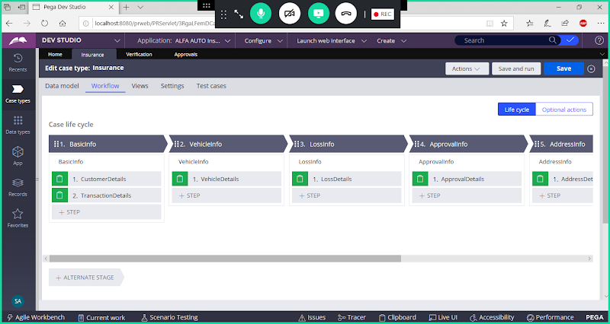

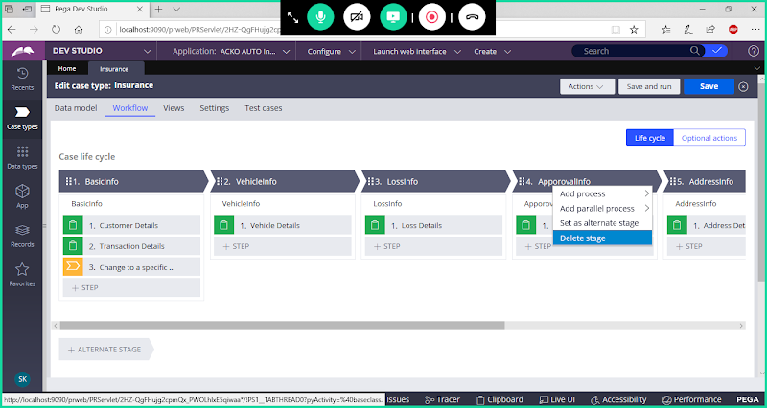

**Delete Stage**

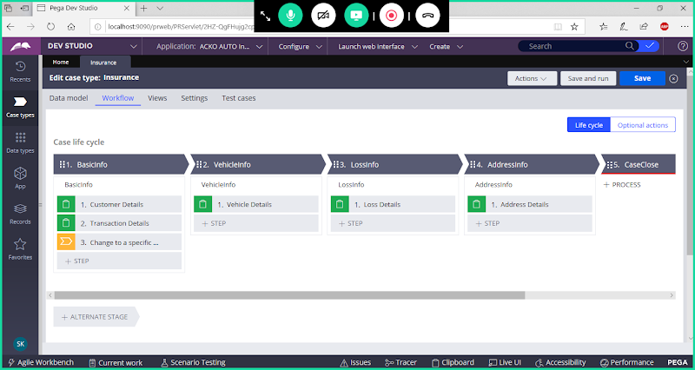

**Also Delete Change Stage step from Stage 1:**

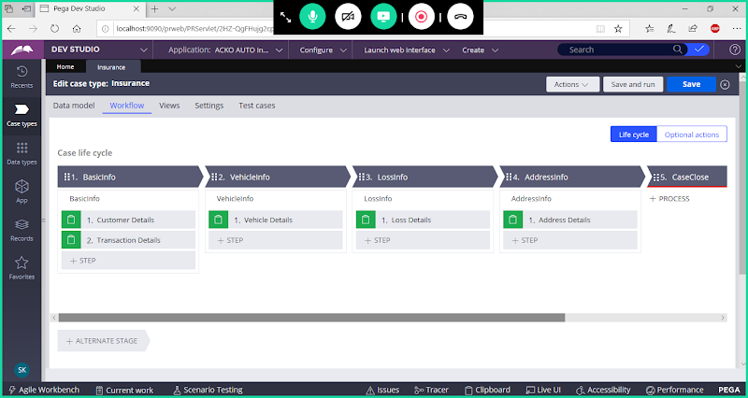

**Save Insurance Case.**

**Instantiation of Children/Child Cases:**

**Open Verification Case Type:**

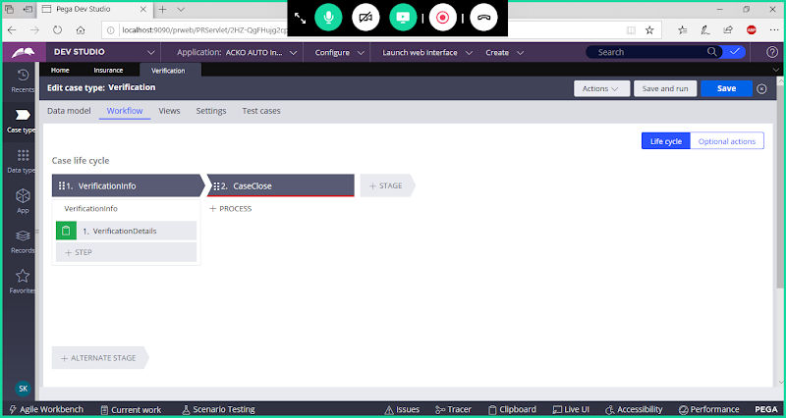

**Go to settings**

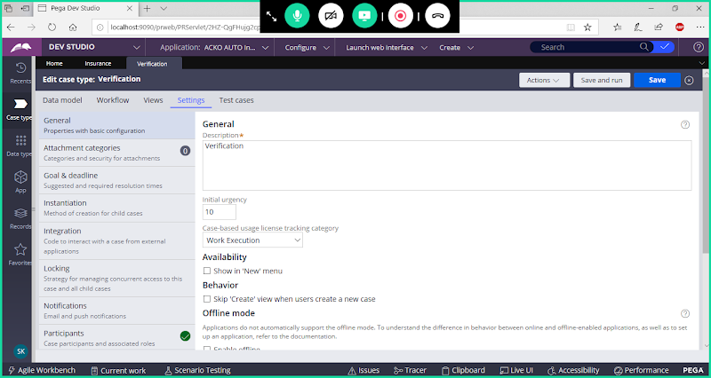

**Click on Instantiation:**

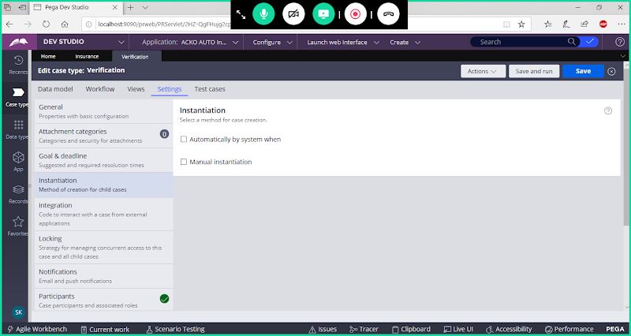

**Select -> Automatically by system ( Means When Parent Case Started Verification case also Gets executed parallel)**

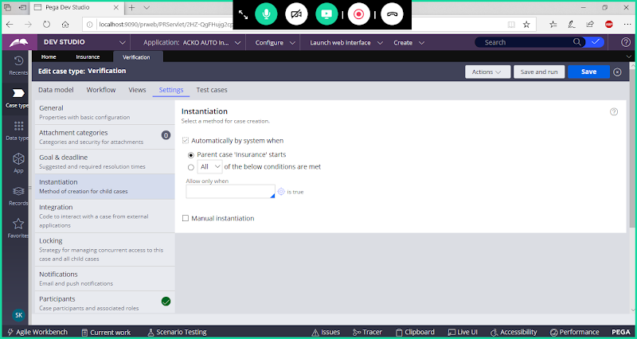

**Save the Case**

**Now Call Approvals Case Inside Insurance Case after LOSS Details step:**

**To Call subcase inside Parent Case we can use Create Case ( Smart Shape - Open this shape from Utilities)**

**Open Insurance Case:**

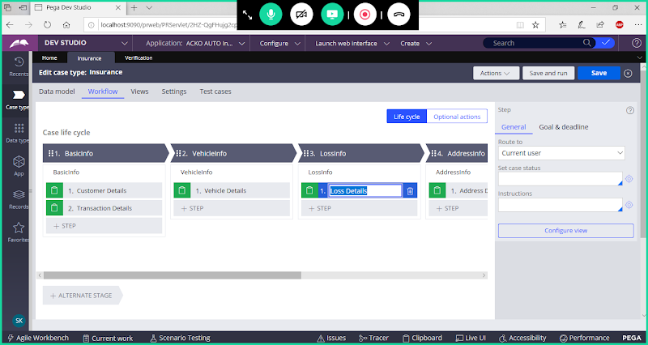

**After Loss Details step -> add New step:**

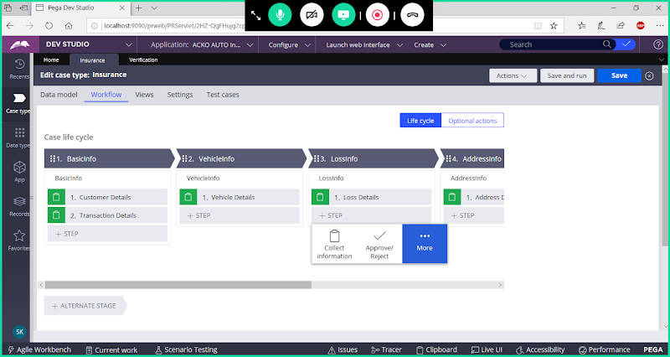

**More-> Automations**

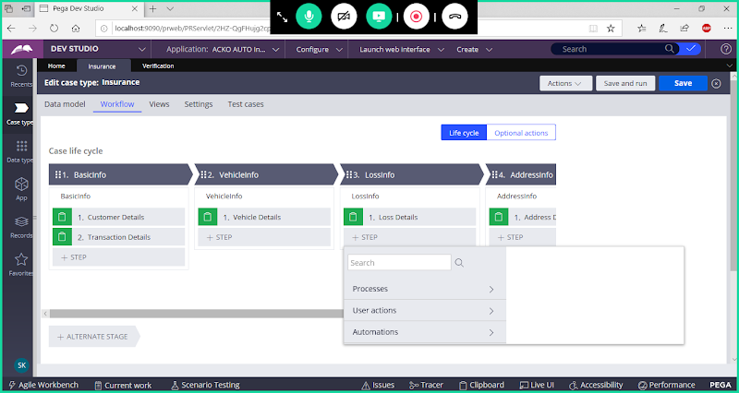

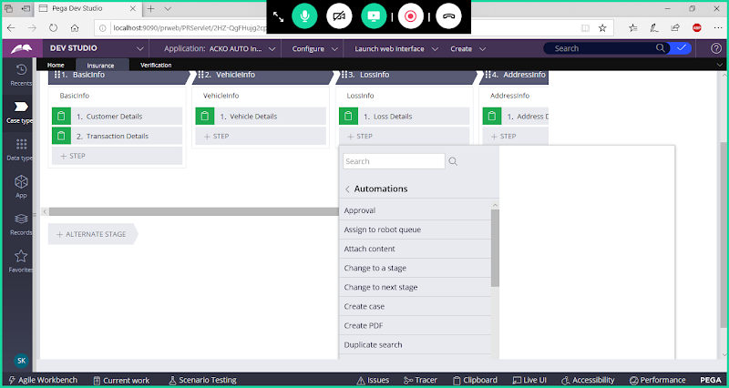

**Select Create Case**

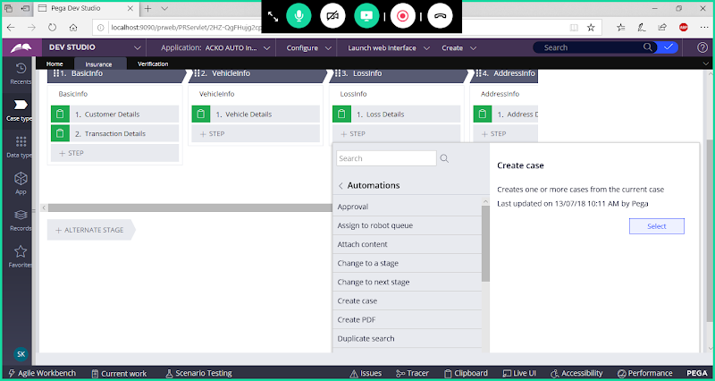

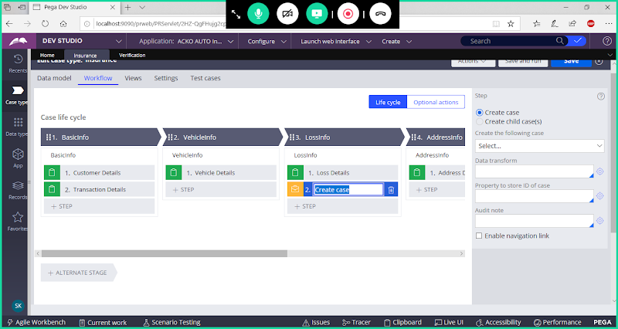

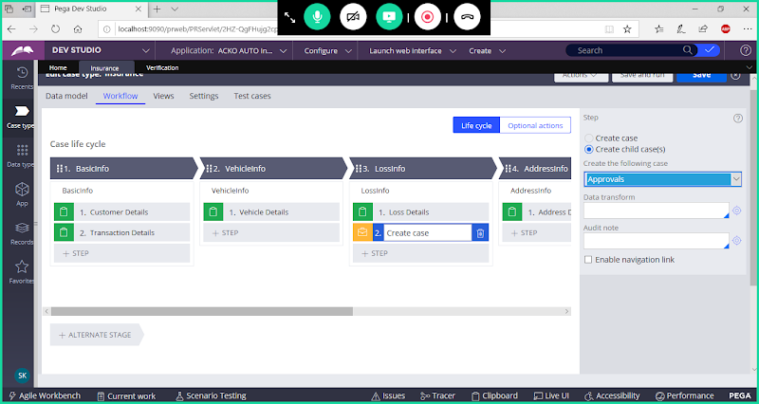

**Save Insurance Case**

**==========**

**Important Parameters in case designer:**

**Calculation: we can perform sum operation ( Expression Rule)**

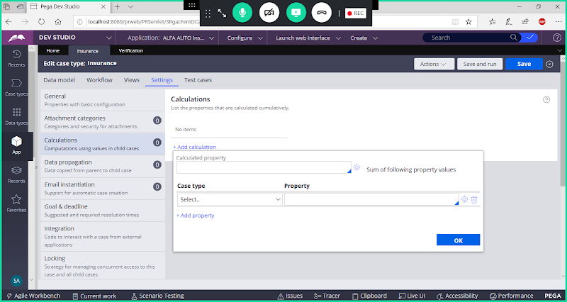

**Available only in Parent Case**

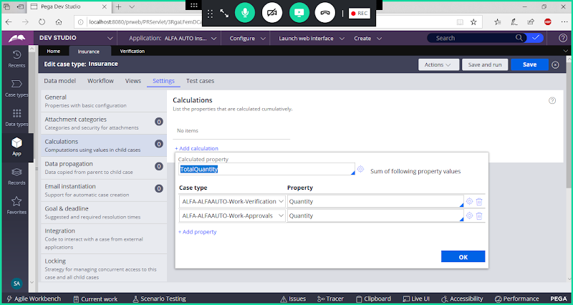

**Electronic Products:   3 Items**

**Grocery Products:   7 items**

**Sum- Total Items : 10 Items**

**Locking :**

**Open Insurance Case Type -> Go to Settings-> Locking**

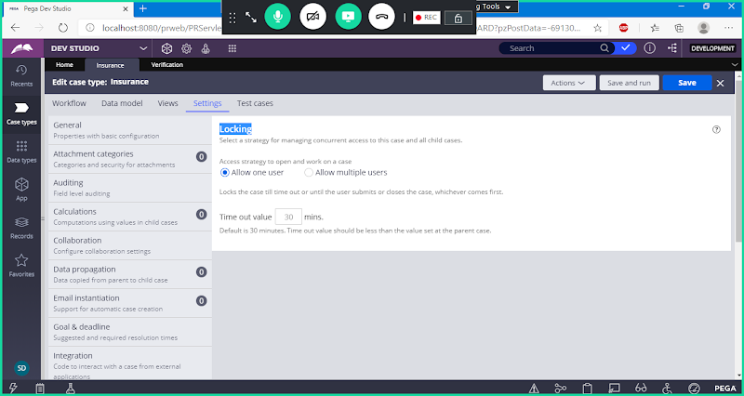

**Open Any Child Case:**

**Go to Settings-> Locking**

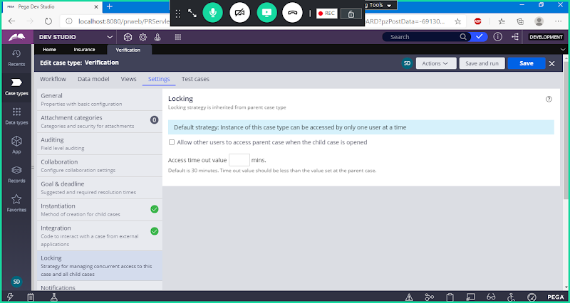

**Case Management:**

**Parallel Processing is Not possible by using Normal Work Flows.**

**To Perform Parallel Processing, we can use Case Management ( Only using Case Designer it is possible)**

**Ex:**

**WO1- Parent Case**

**WO2 - Child**

**Wo3 - Child**

**==**

**To allow parallel processing:**



**Enable: Allow other users to access parent case when the child case is opened. ( This Option we have to enable for every Child Case)**

**Save Case**

**=============**